CMD OF THE ORIENTAL INSURANCE COMPANY LIMITED – SHRI ANJAN DEY
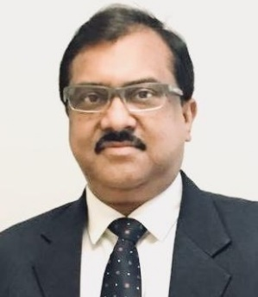
Shri Anjan Dey has assumed charge as Chairman-cum-Managing Director of The Oriental Insurance Company Limited on 12.03.2021.
His career spans over a period of more than 34 years in General Insurance Industry starting in 1986 as a Direct Recruit Officer in New India Assurance Company Limited where he had good experience in various fields of marketing and technical areas across the Country besides heading prestigious Regional Offices at Mumbai. His overseas postings include serving as COO of Aruba Dutch Carribean Islands and as CEO and Managing Director of Tanzindia Assurance Company, Tanzania, for over eight years.
He was promoted to the cadre of General Manager in 2018 and has immense experience in technical, marketing, foreign business and other related areas.
He was elevated to the position of Chairman-cum-Managing Director of The Oriental Insurance Company Limited, vide notification dated 10.03.2021.

